²
Report
Deep Learning Group Project

Group 5:
MBAMALI Somkenechukwu
ADEGBENRO Adeyinka Samuel
DAM Son Quy

Tutor: SANCHEZRAMIREZ Juliana

1. Introduction
Image classification and sequence prediction are fundamental tasks in machine learning, with applications ranging from autonomous vehicles to healthcare. This report presents a detailed analysis of two distinct projects: Flickr Image Classification and Human Activity Recognition (HAR) using Smartphones. The Flickr project focuses on categorizing images into predefined classes using Multilayer Perceptrons (MLPs), Convolutional Neural Networks (CNNs), and Transfer Learning. The HAR project compares Recurrent Neural Networks (RNNs) and CNNs for classifying human activities based on smartphone sensor data.
The report aims to provide a comprehensive understanding of the methodologies, architectures, and results for both projects. It includes explanations of technical terminologies, performance comparisons, and insights into model interpretability. By adhering to a structured format, the report ensures clarity and depth, suitable for both technical and non-technical audiences.

2. Objectives
The objectives of this report are as follows:
- Flickr Image Classification:
  - Develop and compare classification models (MLP, CNN, Transfer Learning) to categorize images into animals, objects, people, scenes, and others.
  - Implement data preprocessing and augmentation techniques to enhance model performance.
  - Experiment with architecture modifications, hyperparameter tuning, and interpretability techniques.
  - Identify the best-performing model and provide recommendations for improvement.
- Human Activity Recognition (HAR):
  - Compare RNN (LSTM, GRU) and CNN architectures for sequence prediction using smartphone sensor data.
  - Apply an attention mechanism to the best RNN model to improve interpretability.
  - Evaluate model performance based on accuracy, loss, training speed, and interpretability.
  - Recommend the optimal model for specific use cases (interpretability vs. efficiency).
- General:
  - Explain all technical terminologies to ensure accessibility.
  - Provide a well-structured, detailed analysis within 10–15 pages.
  - Highlight key takeaways and propose next steps for both projects.

3. Flickr Image Classification
3.1 Dataset and Preprocessing
Dataset: The Flickr dataset comprises 8,000 images divided into training and validation sets. The images are categorized into five classes: animals, objects, people, scenes, and others. A balanced dataset ensures fair representation of each class.
Preprocessing:
- Resizing: All images are resized to 224x224 pixels to standardize input dimensions for neural networks. This reduces computational complexity while preserving essential features.
- Normalization: Pixel values (originally 0–255) are scaled to a range of [0, 1] or standardized to have zero mean and unit variance. Normalization ensures stable and faster convergence during training.
- Data Augmentation: Techniques such as grayscale conversion, rotation, flipping (horizontal and vertical), zooming, brightness adjustments, shearing, and random shifts are applied. Augmentation artificially increases dataset diversity, reducing overfitting by exposing the model to varied image representations.
Terminology:
- Overfitting: When a model performs well on training data but poorly on validation data due to memorizing patterns rather than generalizing.
- Hyperparameter: Configuration settings (e.g., learning rate, batch size) that control the training process, tuned experimentally.
3.2 MLP Models
Why MLP?
This is used as our baseline for comparison between other architectures that will be mentioned later in the report
Multilayer Perceptrons are feedforward neural networks used as a baseline due to their simplicity. They process flattened image data, making them less effective for spatial patterns but useful for initial comparisons.
Implemented Architectures:
- MLP 1 (Model-V1):
  - Layers: 5 (input, 3 hidden, output).
  - Parameters: 805,813 (weights and biases).
  - Activation: ReLU (Rectified Linear Unit) for hidden layers, Softmax for output to produce class probabilities.
  - Performance: Training accuracy 54.0%, validation accuracy 53.3%.
- MLP 2 (Model-V3):
  - Layers: 8 (input, 6 hidden, output).
  - Parameters: 3,221,061 (increased due to deeper architecture).
  - Regularization: Dropout (randomly deactivates neurons during training to prevent overfitting) and L2 regularization (penalizes large weights).
  - Performance: Training accuracy 55.6%, validation accuracy 53.3%.
Comparison:
Model | Layers | Parameters | Activation | Accuracy (Train) | Accuracy (Val)
MLP 1 (V1) | 5 | 805,813 | ReLU + Softmax | 54.0% | 53.3%
MLP 2 (V3) | 8 | 3,221,061 | ReLU + Softmax | 55.6% | 53.3%
Observation: Both MLP models achieved modest performance, with MLP 2 slightly better on training data due to increased capacity. However, validation accuracies remained similar, indicating limited generalization for image data.

3.3 CNN Models
Why CNN? Convolutional Neural Networks excel at image classification by leveraging convolutional layers to extract spatial features (e.g., edges, textures) and pooling layers to reduce dimensionality.
Baseline Architecture:
- Layers:
  - Conv2D(8, (2,2)): 8 filters of size 2x2 to extract basic features.
  - MaxPooling2D: Reduces spatial dimensions (e.g., 224x224 to 112x112) while retaining important features.
  - Conv2D(64, (3,3)): 64 filters of size 3x3 for more complex features.
  - MaxPooling2D: Further reduces dimensions.
  - Dense(128, ReLU): Fully connected layer for high-level reasoning.
  - Dense(output, Softmax): Outputs class probabilities.
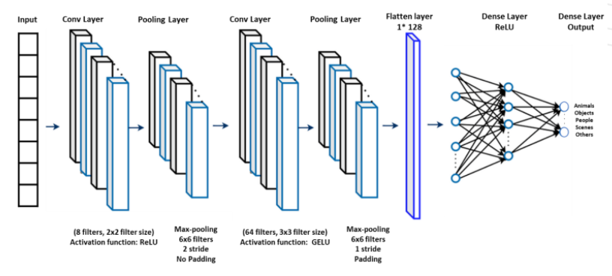
- Training:
  - Optimizer: Adam (adaptive learning rate algorithm).
  - Loss: Categorical Crossentropy (measures error for multi-class classification).
  - Epochs: 20 (number of full passes through the training data).
- Model Performance: Training accuracy 72.7%, validation accuracy 58.6%, parameters 93,795,757.
Observation: The baseline CNN outperformed MLPs but showed overfitting (high training accuracy, lower validation accuracy).
Experimentation:
- CNN Model v1: Increased filter sizes → Training accuracy 84.03%, validation accuracy 53.76% (strong overfitting).
- CNN Model v2: Added dropout (0.5) → Training accuracy 65.81%, validation accuracy 60.24% (better generalization).
- CNN Model v3: 3 Conv layers (32, 64, 128 filters), dropout (0.5) → Training accuracy 68.13%, validation accuracy 61.61%.
- CNN Model v4 (Best): 3 Conv layers, SGD optimizer (learning rate 0.01, momentum 0.9), ReduceLROnPlateau (reduces learning rate when performance plateaus) → Training accuracy 70.08%, validation accuracy 62.13%.
Comparison:
Experiment | Changes | Accuracy (Train) | Accuracy (Val) | Comments
Baseline CNN | Default | 72.73% | 58.60% | Overfits slightly
CNN Model v1 | More filters | 84.03% | 53.76% | Strong overfitting
CNN Model v2 | More filters + Dropout (0.5) | 65.81% | 60.24% | Dropout improves regularization
CNN Model v3 | 3 Conv layers (32, 64, 128), Dropout (0.5), Adam | 68.13% | 61.61% | Better generalization
CNN Model v4 | 3 Conv layers, SGD (0.01 LR, momentum 0.9), ReduceLROnPlateau | 70.08% | 62.13% | Best validation accuracy

Data Augmentation Impact:
- Applied flipping, rotation, zooming, shearing, etc.
- Retrained CNN Model v4 → Validation accuracy improved from 62.1% to 62.3%.
3.4 Transfer Learning
Why Transfer Learning? Pretrained models like EfficientNetB0, trained on ImageNet (1.4M images, 1,000 classes), provide robust feature extractors, reducing training time and data requirements.
Approach:
- Frozen EfficientNet: Base layers frozen, new classifier head trained.
  - Performance: Training accuracy 53.4%, validation accuracy 53.3%.
- Fine-Tuned EfficientNet: Unfroze last 10 layers, added dropout (0.4).
  - Performance: Training accuracy 54.8%, validation accuracy 53.3%.
Observation: Transfer learning underperformed compared to CNNs, possibly due to insufficient learning rate tuning or dataset mismatch with ImageNet.
3.5 Model Interpretability
Activation Visualization:
- Early layers detect edges and textures; deeper layers capture abstract features (e.g., shapes, objects).
- Visualizations confirm the model focuses on high-contrast, textured regions.
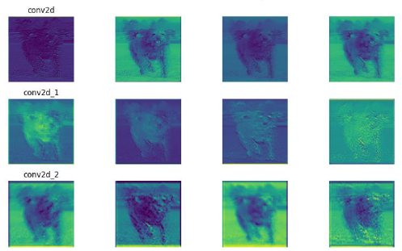
Grad-CAM (Gradient-weighted Class Activation Mapping):
- Generates heatmaps highlighting regions influencing predictions.
- Example: For a "person" class, the heatmap emphasized the foreground subject, validating correct focus.
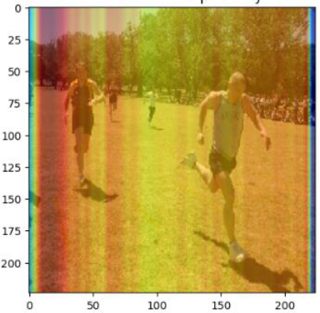
3.6 Overall Model Comparison
Model | Accuracy (Train) | Accuracy (Val) | Comments
MLP 1 | 54.0% | 53.3% | Baseline, poor generalization
MLP 2 | 55.6% | 53.3% | Slightly better training performance
Baseline CNN | 72.7% | 58.6% | Overfits, needs regularization
CNN Model v4 (Best) | 70.1% | 62.1% | Best without augmentation
CNN Model v4 + Augmentation | ~70% | 62.3% | Best overall
Frozen EfficientNet | 53.4% | 53.3% | No improvement over MLPs
Fine-Tuned EfficientNet | 54.8% | 53.3% | Fine-tuning ineffective
Best Model: CNN Model v4 with data augmentation (62.3% validation accuracy).

3.7 Key Takeaways
- CNNs significantly outperformed MLPs due to their ability to capture spatial features.
- Data augmentation and regularization (dropout, SGD with momentum) were critical for improving generalization.
- Transfer learning was less effective, likely due to suboptimal hyperparameter tuning.
- Interpretability techniques (Grad-CAM) confirmed the model’s focus on relevant image regions.

4. Human Activity Recognition (HAR)
4.1 Dataset Description
Dataset: The HAR dataset contains accelerometer and gyroscope signals from smartphones worn by 30 volunteers performing six activities: walking, sitting, standing, laying, walking upstairs, and walking downstairs.
- Features: 561 extracted from raw signals (e.g., mean, standard deviation).
- Samples: 7,352 (training), 2,947 (test).
- Task: Many-to-one classification (predict activity from a sequence of sensor data).
Why RNNs? Recurrent Neural Networks, particularly LSTMs (Long Short-Term Memory) and GRUs (Gated Recurrent Units), are designed for sequential data, capturing temporal dependencies critical for activity recognition.
4.2 RNN Experimentation
Models:
- Baseline: 2 layers, 64 units, dropout (0.5).
- Simplified: 1 layer, 32 units (reduced complexity).
- Complex: 3 layers, 128 units (increased capacity).
Results:
- Best Model: Complex LSTM (Accuracy: 91.52%, Loss: 0.2446).
- Complex GRU: Accuracy 90.97%, Loss 0.3567.
- Observation: Deeper models with more units better capture temporal patterns.
4.3 Attention Mechanism
Why Attention? Attention mechanisms weigh the importance of different time steps, improving interpretability by highlighting key moments in the sequence.
Implementation:
- Applied to Complex LSTM.
- Computes importance scores and reweighs inputs.
- Performance: Accuracy 91.28%, Loss 0.2666 (slight decrease vs. Complex LSTM).
- Benefit: Visualizes which time steps contribute most to predictions.
4.4 CNN Experimentation
Models:
- Baseline: 2 Conv1D layers, 64 filters, dropout (0.5).
- Simplified: 1 Conv1D layer, 32 filters.
- Complex: 4 Conv1D layers, 128 filters, dropout (0.6).
Results:
- Best Model: Complex CNN (Accuracy: 91.48%, Loss: 0.4590).
- Observation: Deeper architectures improve accuracy but increase computational cost.
4.5 RNN vs. CNN Comparison
Metric | RNN (Complex LSTM) | CNN (Complex CNN)
Accuracy | 91.52% | 91.48%
Loss | 0.2446 | 0.4590
Training Speed | Slower | Faster
Interpretability | High (with attention) | Moderate
Recommendation:
- LSTM with Attention: Preferred for interpretability-critical applications.
- Complex CNN: Ideal for scenarios prioritizing speed and efficiency.

5. Next Steps
- Flickr Image Classification:
  - Explore advanced architectures (e.g., ResNet, Vision Transformers).
  - Optimize transfer learning with grid search for learning rates.
  - Increase dataset size or use synthetic data generation.
  - Enhance interpretability with SHAP or LIME.
- Human Activity Recognition:
  - Experiment with hybrid CNN-RNN models to combine spatial and temporal learning.
  - Test additional attention variants (e.g., self-attention).
  - Evaluate models on real-time data streams.
  - Reduce model complexity for deployment on resource-constrained devices.

6. Conclusion
The Flickr Image Classification project demonstrated that CNNs, enhanced with data augmentation and regularization, outperform MLPs and transfer learning for the given dataset, achieving a validation accuracy of 62.3%. Interpretability techniques like Grad-CAM provided valuable insights into model behavior.
The HAR project showed that both Complex LSTM (with attention) and Complex CNN are highly effective for sequence prediction, with accuracies around 91.5%. LSTMs offer superior interpretability, while CNNs excel in training speed.
Both projects underscore the importance of architecture design, regularization, and interpretability in achieving robust machine learning models. Future work should focus on advanced architectures, hyperparameter optimization, and real-world deployment.

7. References
- Krizhevsky, A., et al. (2012). "ImageNet Classification with Deep Convolutional Neural Networks." NeurIPS.
- Hochreiter, S., & Schmidhuber, J. (1997). "Long Short-Term Memory." Neural Computation.
- Selvaraju, R. R., et al. (2017). "Grad-CAM: Visual Explanations from Deep Networks." ICCV.
- Anguita, D., et al. (2013). "A Public Domain Dataset for Human Activity Recognition Using Smartphones." ESANN.

